HPC Assignment 4

Code (Add Large Vectors in Parallel):
#include<stdio.h>
#include<iostream>
#include<cstdlib>
//****important to add following library to allow a programmer to use parallel paradigms*****
#include<omp.h>
using namespace std;
#define MAX 100
int main()
{
int a[MAX],b[MAX],c[MAX],i;
printf("\n First Vector:\t");
//Instruct a master thread to fork and generate more threads to process following loop structure
#pragma omp parallel for
for(i=0;i<MAX;i++)
{
a[i]=rand()%1000;
}
//Discuss issue of this for loop below-if we make it parallel, possibly values that get printed will not be in sequence as we dont have any control on order of threads execution
for(i=0;i<MAX;i++)
{
printf("%d\t",a[i]);
}
printf("\n Second Vector:\t");
#pragma omp parallel for
for(i=0;i<MAX;i++)
{
b[i]=rand()%1000;
}
for(i=0;i<MAX;i++)
{
printf("%d\t",b[i]);
}
printf("\n Parallel-Vector Addition:(a,b,c)\t");
#pragma omp parallel for
for(i=0;i<MAX;i++)
{
c[i]=a[i]+b[i];
}
for(i=0;i<MAX;i++)
{
printf("\n%d\t%d\t%d",a[i],b[i],c[i]);
}
}

Output:

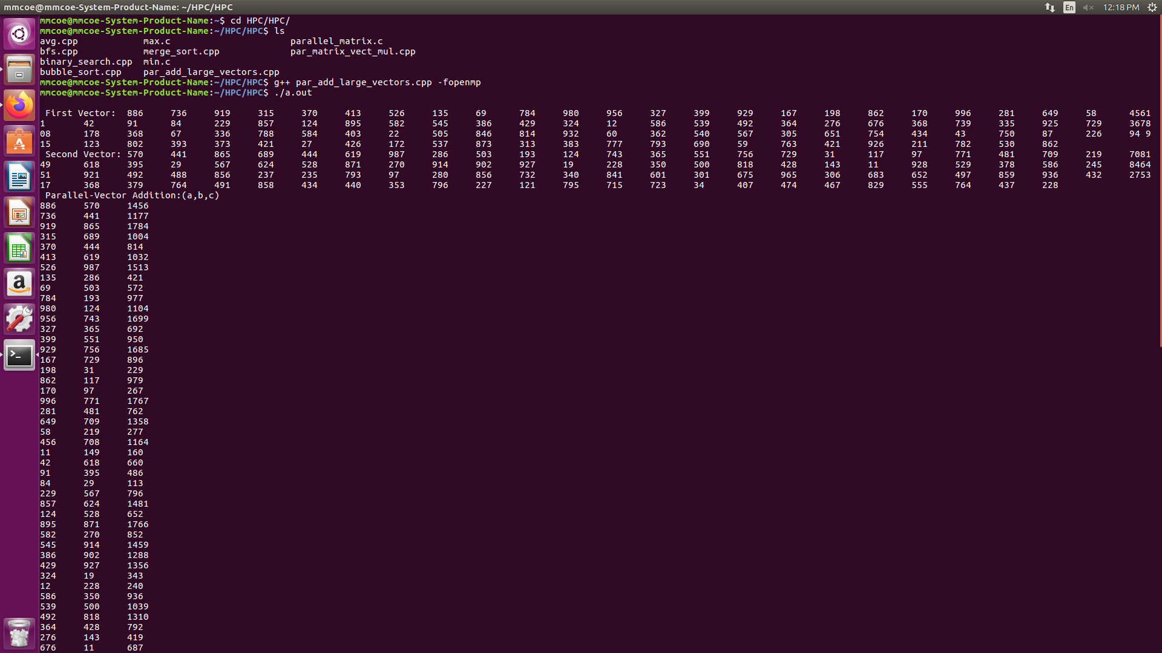
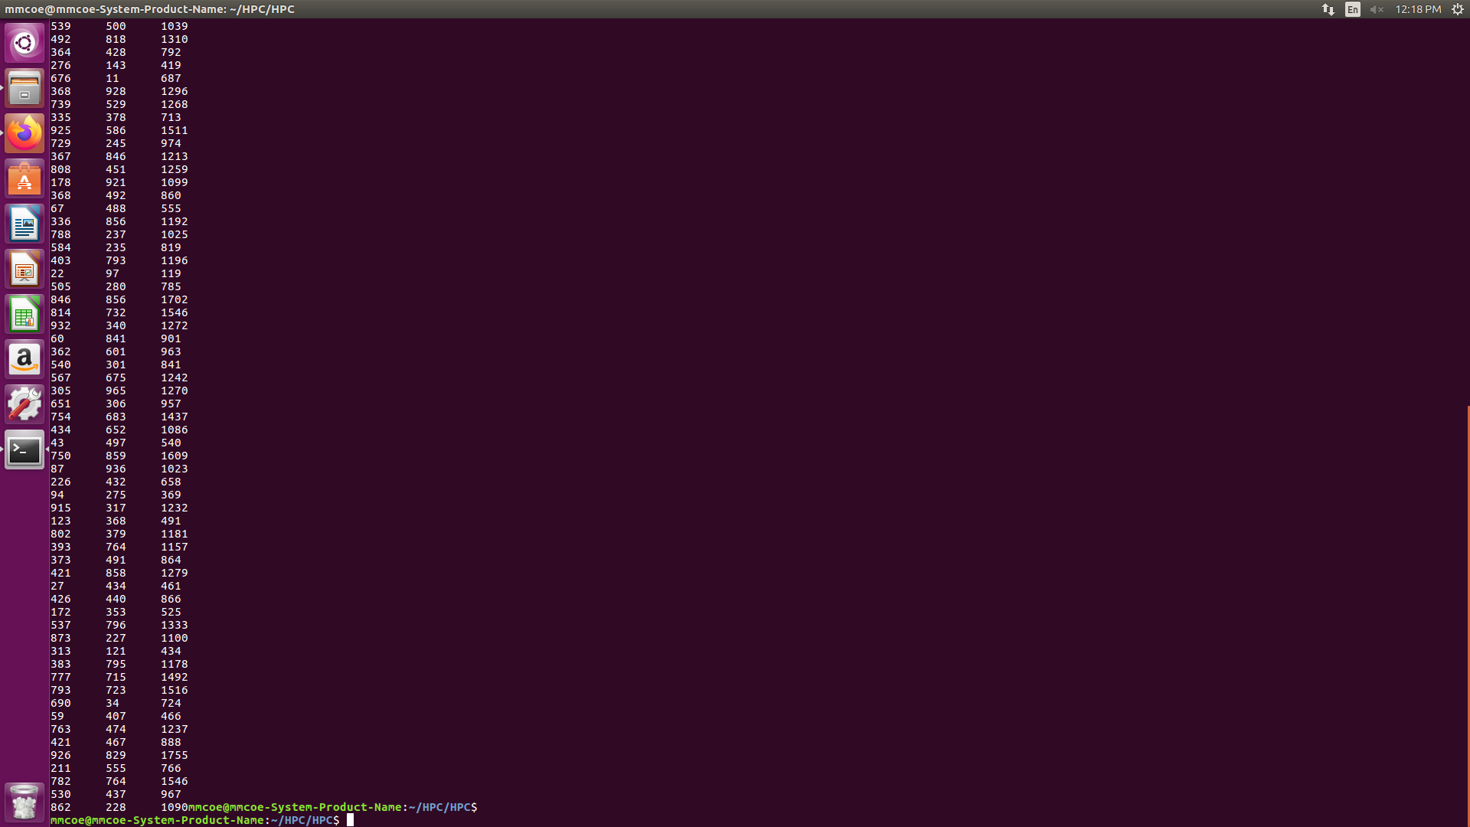

Code (Multiply Matrix and Vector in Parallel):
#include<stdio.h>
#include<iostream>
#include<cstdlib>
#include<omp.h>
using namespace std;
int main()
{
int m=3,n=2;
int mat[m][n],vec[n],out[m];
//matrix of size 3x2
for(int row=0;row<m;row++)
{
for(int col=0;col<n;col++)
{
mat[row][col]=1;
}
}
//display matrix
cout<<"Input Matrix"<<endl;
for(int row=0;row<m;row++)
{
for(int col=0;col<n;col++)
{
cout<<"\t"<<mat[row][col];
}
cout<<""<<endl;
}
//column vector of size 2x1
for(int row=0;row<n;row++)
{
vec[row]=2;
}
//display vector
cout<<"Input Col-Vector"<<endl;
for(int row=0;row<n;row++)
{
cout<<vec[row]<<endl;
}
//before multiplication check condition, no_of_cols(matrix)==no_of_rows(vector)
#pragma omp parallel
{
#pragma omp parallel for
for(int row=0;row<m;row++)
{
out[row]=0;
for(int col=0;col<n;col++)
{
out[row]+=mat[row][col]*vec[col];
}
}
}
//display resultant vector
cout<<"Resultant Col-Vector"<<endl;
for(int row=0;row<m;row++)
{
cout<<"\nvec["<<row<<"]:"<<out[row]<<endl;
}
return 0;
}

Output:
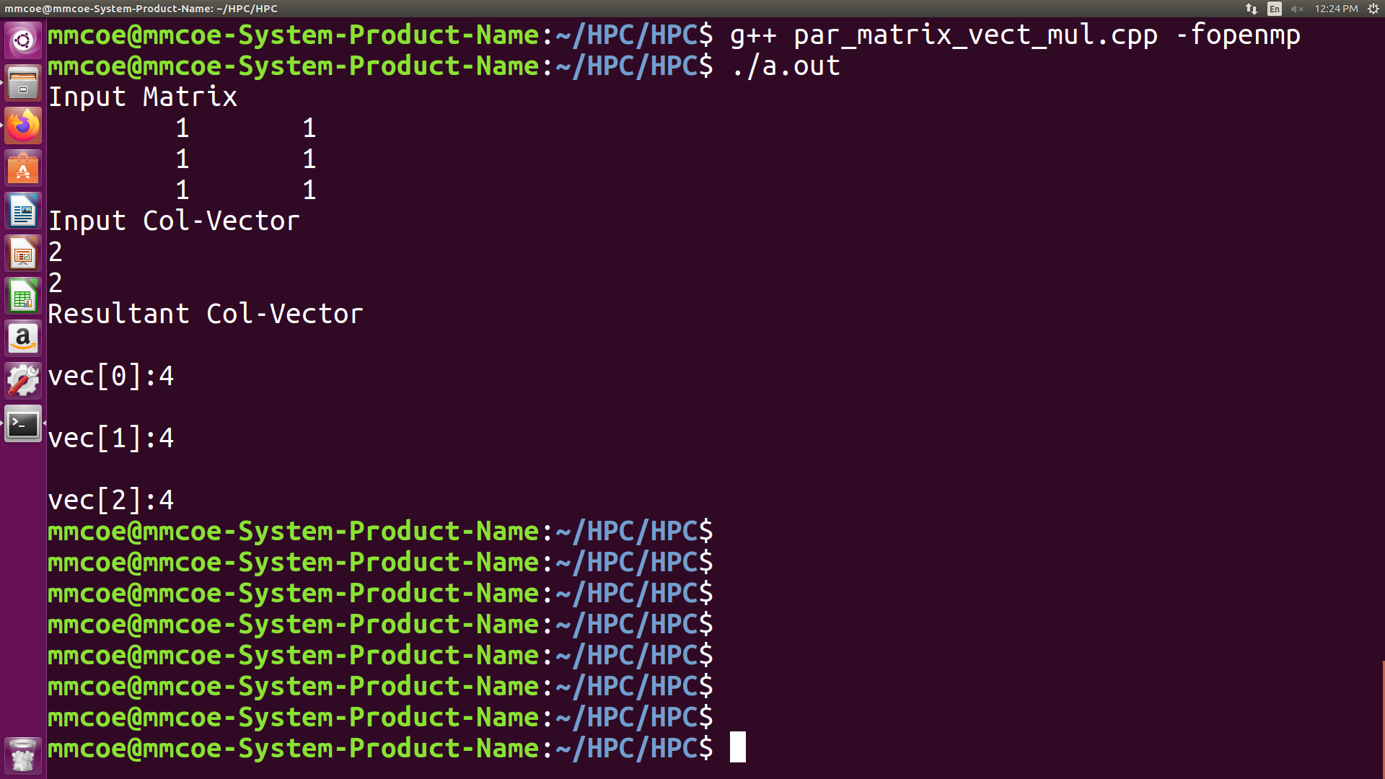
Code (Multiply Two Matrices in Parallel):
// Matrix-Matrix Multiplication
#include <stdio.h>
#include <stdlib.h>
#include <time.h>
#include<omp.h>
#define N 4

float A[N][N], B[N][N], C[N][N]; // declaring matrices of NxN size
int main ()
{
/* DECLARING VARIABLES */
int i, j, m; // indices for matrix multiplication
float t_1; // Execution time measures
clock_t c_1, c_2;
/* FILLING MATRICES WITH RANDOM NUMBERS */
for(i=0;i<N;i++)
{
for(j=0;j<N;j++)
{
A[i][j]= (rand()%5);
B[i][j]= (rand()%5);
}
}
// Display input matrix A:
printf("Matrix A:\n");
for(i=0;i<N;i++)
{
for(j=0;j<N;j++)
{
printf("%f\t",A[i][j]);
}
printf("\n");
}
// Display input matrix B:
printf("Matrix B:\n");
for(i=0;i<N;i++)
{
for(j=0;j<N;j++)
{
printf("%f\t",B[i][j]);
}
printf("\n");
}
c_1=clock(); // time measure:
/* MATRIX MULTIPLICATION */
printf("Max number of threads: %i \n",omp_get_max_threads());
#pragma omp parallel
#pragma omp single
{
printf("Number of threads: %i \n",omp_get_num_threads());
}
#pragma omp parallel for private(m,j)
// #pragma omp_set_num_threads(8)
for(i=0;i<N;i++)
{
for(j=0;j<N;j++)
{
C[i][j]=0.; // set initial value of resulting matrix C = 0
for(m=0;m<N;m++)
{
C[i][j]=A[i][m]*B[m][j]+C[i][j];
}
}
}
// Display input matrix B:
printf("Matrix C:\n");
for(i=0;i<N;i++)
{
for(j=0;j<N;j++)
{
printf("%f\t",C[i][j]);
}
printf("\n");
}
/* TIME MEASURE + OUTPUT */
c_2=clock(); // time measure:
t_1 = (float)(c_2-c_1)/CLOCKS_PER_SEC; // in seconds; - time elapsed for job row-wise
printf("Execution time: %f(in seconds) \n",t_1);
/* TERMINATE PROGRAM */
return 0;
}

Output:
